The Effect of Drag Forces on Support Strut Vortex Shedding

Lucas Simmonds | Charlie Nitschelm | Ross Thyne

Contents

Table of Tables 2

Table of Figures 2

Project Objectives 2

Methodologies 3

Analytics 3

Experimental 6

Evaluation 6

Equipment 6

Miscellaneous 7

Facilities 7

Support 7

Project Schedule 7

# Table of Tables

Table 1 Experimental Parameters 4

Table 2 Predicted Values for Vortex Shedding Data 5

Table 3 Coefficient of drags for the two different test setups for the strut with and without fairings 6

# Table of Figures

Figure 1 Strouhal Number vs Reynolds Number for a Circular Cylinder [Handbook of Experimental Fluid Mechanics] 4

Figure 2 Coefficient of Drag vs Reynolds Number for a Circular Cylinder [Handbook of Experimental Fluid Mechanics] 5

# Project Objectives

Is there a relationship between the amount of drag on a strut and its apparent vortex shedding? This design of experiment will include quantitatively measuring the total drag force on different cross-sections of struts and their apparent natural frequency induced by vortex shedding. The Living Bridge Project, ongoing since 2014, has reached a need for the understanding of the complex velocity profile created by the bridge pier and the wake of the tidal turbine. Vortex shedding is a known phenomenon that is dependent on the blockage a bluff body imparts on a moving fluid. Getting controlled, laboratory data on the vortex shedding experienced on the strut with a certain force of drag will assist the team with the analysis of field data at the Memorial Bridge Tidal Turbine. This will be completed by attaching the strut to the tow tank in Chase Hall. The strut will be equipped with fairings and no fairings to understand how the decrease in drag force affects the vortex shedding measurements. The data from the load cells attached at the carriage will be used to calculate the drag force on the strut through the test. The drag force will be experimentally determined for both the circular cylinder and the circular cylinder with fairings and compared with analytical models for the generic geometries being used. By recording the velocity at which the strut moves through the water, the Reynolds and Strouhal Number can be calculated. The Strouhal number is a dimensionless number that describes oscillating flow mechanisms. We will be comparing our experimental Strouhal numbers with tabulated values. Once the natural frequency induced by the vortex shedding has been identified, this information can be further used to understand velocity measurements taken in the field.

# Methodologies

## Analytics

In order to understand our results, we must first make predictions as to what the behavior of our system will be. We started by first calculating the Reynolds Number for the circular cylinder and the circular cylinder with fairings using the equation below,

This formula can be used for both the circular cylinder and the circular cylinder with fairings because the fairings were designed as NACA 0020 airfoils with the same diameter as the circular cylinder. Using the figure below from the textbook, *Handbook of Experimental Fluid Mechanics*, which contains experimental data on the relationship between Reynolds Number and Strouhal Number for a circular cylinder we could find the Strouhal Number for our experiment.

Figure 1 Strouhal Number vs Reynolds Number for a Circular Cylinder [Handbook of Experimental Fluid Mechanics]

Using the Strouhal Number obtained from Figure 1 we can use the equation,

To solve for the dominant natural frequency that we expect to see in our Fast Fourier Transform. This value can be compared to the actual frequency we obtain through a Fast Fourier Transform of the experimental data. Although the circular cylinder with fairings will be subjected to the same Reynolds Number as the circular cylinder, we are expecting the no shedding frequency. Tables of the experimental parameters and predicted behaviors can be found below.

Table 1 Experimental Parameters

|  |  |  |  |  |  |  |
| --- | --- | --- | --- | --- | --- | --- |
|  | Diameter [m] | Chord [m] | Velocity [m/s] | Density (H2O) [kg/m3] | Dynamic Viscosity () [Pa s] | Kinematic Viscosity () [m2/s] |
| Circular Cylinder | 0.06 | N/A | 2 | 998.2 | 1.002*10-3 | 1.002*10-6 |
| Circular Cylinder with Fairings | 0.06 | 0.152 | 2 | 998.2 | 1.002*10-3 | 1.002*10-6 |

Table 2 Predicted Values for Vortex Shedding Data

|  |  |  |  |  |
| --- | --- | --- | --- | --- |
|  | Reynolds Number (Re) | Reynolds Number based off chord (Rec) | Strouhal Number (St) | Shedding Frequency (Hz) |
| Circular Cylinder | 119,544 | N/A | 0.19 | 6.33 |
| Circular Cylinder with Fairings | 119,544 | 304,100 | 0 | 0 |

In order to test the effectiveness of the fairings, we will measure and compare the drag force on the circular cylinder and circular cylinder with fairings. First, we used the calculated Reynolds Numbers to estimate the coefficient of drag for a circular cylinder using the figure below from the textbook, *Handbook of Experimental Fluid Mechanics*, which contains data on Coefficient of Drag vs. Reynolds Number for a circular cylinder.

Figure 2 Coefficient of Drag vs Reynolds Number for a Circular Cylinder [Handbook of Experimental Fluid Mechanics]

Using the value for coefficient of drag obtained from our Reynolds Number, we can estimate the drag force on the circular cylinder using the equation below,

Where is the density of the fluid, is obtained from Figure 2, is the area of the cylinder exposed to the flow, and is the velocity of the flow. For the circular cylinder with fairings the chord length of our airfoils must be used to determine the Reynolds Number. This number can be found in Table 2. Using this Reynolds Number we checked tabulated values for the coefficient of drag of a NACA 0020 airfoil at a 0-degree angle of attack. The calculated values for the drag force can be found in the table below.

Table Coefficient of drags for the two different test setups for the strut with and without fairings

|  |  |  |
| --- | --- | --- |
|  | Coefficient of Drag (CD) | Force of Drag (FD) [N] |
| Circular Cylinder | 1.3 | 218 |
| Circular Cylinder with Fairings | 0.018 | 3 |

## Experimental

The current state of the Tow Tank in the Chase Engineering building has the infrastructure to easily equip a new mount to utilize load cells to measure force on the strut through the test. Two 100 lb. load cells will be used for the circular cylinder where 218 N drag forces are predicted, and 10 lb. load cells will be used for the fairing test as the amount of drag force the strut will encounter is much smaller. Many of the funds for this project will be used on the material needed for the mount. Once the mount has been assembled and attached to the carriage, the load cells can be calibrated to get a precise conversion factor from voltage to force. Mounting brackets will be used as the fixture of the strut, allowing it to fall into the water and tighten until fixed to the mount. The PVD will record the velocity of the water, allowing the vortex shedding to be analyzed, and the natural frequency of the system to be calculated. The resolution that the AVD must record at must be at least 12.6 Hz. This was calculated by using the Nyquist frequency, which is twice the maximum detectable frequency of the system. Once the system begins, the carriage will move at a constant speed of 2 meters per second, simulating a water current of the same velocity in the opposite direction. The water that is passing through the data collecting area of the ADV will need to be seeded to ensure the ADV has a physical object to operate its signal off. Seeding will be performed by using a siphon pump to fill the pipe with seed that will then travel into the tank as the carriage moves across the length of the tow tank. This may need to be repeated between switching out the pipe for the fairing. After the experiment runs for just the strut with no fairings, a duplicate test will be run again with fairings attached to the strut to decrease the force of drag on the object through the test. Two separate data sets would be recorded, being the force of drag and vortex shedding, for each test.

## Evaluation

The analytical analysis of drag force on the strut can be compared to experimental data collected from the test to assess the error in our analytical predictions. The data of vortex shedding recorded from the ADV displaying the struts natural frequency can then be compared with the difference in the amount of drag force it experienced during the test. This information of the vortex shedding of the strut and its variation with the drag force imparted will provide the field tests with a context that can help with analysis of the applied situation within the Living Bridge Project.

# Equipment

## Miscellaneous

* 2 Load Cells
* ADV and mounting system
* 2.375” Pipe
* Pipe with connected Fairing
* Seeding
* 1 T-slotted Framing $27.30
* 6 Silver Corner Bracket $37.56 Total
* 2 Packs of 4 SS End-Feed Fasteners $9.02

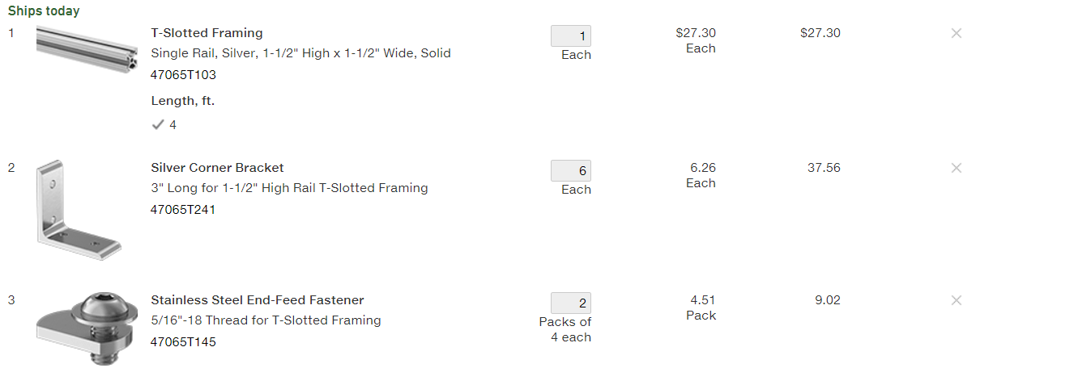

# Facilities

The test would be performed at the Chase Ocean Engineering lab in the UNH Tow Tank. We will be using the track cart on the tow tank and attaching our system to it via a side mounting mechanism of our design. An integrated DAQ system will be utilized to record the data from the test, which is already a system integrated within the carriage.

# Support

Support is needed with regards to using the ADV as a system and understanding the data that is collected by the instrument. Kaelin is the assumed source of information in this situation in complement to our own personal research. Support will also be needed in the operational procedure of running the UNH Tow Tank and the connected data collection system, to ensure our experiment is run properly and the data is collected from the sources we need. The water must be seeded as it is passing through the ADV’s data recording area; however, we will most likely be able to do this ourselves with a little bit of guidance from people who are experienced with the Tow Tank.

# Project Schedule

